Survey on Virtual Machine

Edison Tsui Ka Wing Zakaria Lamliki
kwtsui@comp.nus.edu.sg zakaria.lamliki@gmail.com

ABSTRACT
Researches on virtualization dated back to 1970s, while researches focused on multiplexing services in mainframe. However, due to the drop of hardware cost and the introduction of modern multitasking Operating System, virtualization researches fall to its valley. Recently, the resurgence of virtualization technology has changed Enterprises’ IT strategy from “one application one machine” to multiplexing applications/services into one machine, which is defined as Virtualization 1.0. Service consolidation is an on-going trend and is driven by better security and reliability that virtualization provided.

This literature survey discusses the trends of development of virtual machine, including pure virtualization, para-virtualization, binary translation, pre-virtualization and hardware-assisted virtualization. In the later part, we examine the security and performance benefits and challenges brought by virtual machine monitor (VMM).

Keywords
Virtual Machine Monitors

- INTRODUCTION
The origin of virtualization technology dated back to 1970s [1], in which the Virtual machine Monitor (VMM) came into being as a thin software-abstraction layer between hardware and system software. VMM enabled partitioning a hardware platform into one or more virtual machines in which unmodified operating systems (OS) could run on top of it as if it was running on top of native hardware. Though VMM displayed its advantage in multiplexing hardware among multiple applications, the growth of modern multitasking OS and the drop of hardware cost [2] eroded the value of VMM which was used to be run on mainframe.

In the 1990s, Stanford University Researchers looked into the potential of virtual machine to overcome the difficulties that operating systems development was not in the same pace with hardware development, such as, massively parallel processing machine (MPP). The research showed that researchers could make use of virtualization technology and enable existing operating systems to enjoy performance gain without significant modification [6]. In addition, later researches found virtualization could be applied in fields like mobility, security and management problem.

Nowadays, the bloom of VMM opens up a new opportunity, server/service consolidation, to the industry. With the increasing complexity of application, in which some may be fragile and vulnerable, industry adopts a “one-application-one-machine” philosophy for strict service encapsulation to maintain a reliable performance. However, this will bring low utilization rate, approximately 20%. VMM provides a vehicle for multiplexing, isolation, security and migration.

Though the listed advantages depict a rosy prospect of VMM, these improved performance and features are originated from researches that overcome various hardware virtualization challenges, including CPU virtualization, Memory virtualization and I/O virtualization. Various researchers and VMM vendors attack the problem by different approaches. We will discuss some of the approaches, including, pure virtualization, para-virtualization, binary translation, pre-virtualization and hardware-assisted virtualization. In the later part of the text, we will discuss on the upcoming challenges, like possible attack on virtual machine, namely virtual machine based rootkit (VMBR) [19].

The rest of the paper is organized as follows. We cover related work in Section 2. Following this, we summarize the classification of VMM and existing VM products in Section 3. In Section 4, we discuss the software and hardware virtualization techniques in VMM and how the techniques overcome some of the performance overhead. In Section 5, we discuss the security issue in VMM and researches using VMM to enhance security. Lastly, we conclude with discussion in Section 6.

- RELATED WORK
This literature survey follows recent survey papers, “Virtual Machine Monitors: Current Technology and Future Trends” [2] in 2005 and “Survey of System Virtualization Technique”[5] in 2004. We would like to update the [2] and [5] on recent virtualization researches including hardware advancement, like Intel VT [14], AMD SVM [15], and software technique, like Binary Translation [13] and Pre-virtualization [16].

- BACKGROUND
System virtualization allows multiple Operating System (OS) to run on top of a piece of hardware by hardware partitioning or via hypervisor, also called (Virtual Machine Monitor, VMM). The hardware partitioning approach subdivides physical server intro fractions, each can run an OS. Hypervisor approach inserts a layer of code between hardware and operating system and allow multiple guest OS to run on top of it. The advantages over hardware partitioning are resource dynamic allocation and sharing among OS as hypervisor has full control over underlying hardware. In this section, we will discuss the three types of hypervisors, namely Type 1, Type 2 and Hybrid Hypervisor and summarize existing VMM projects.

  - CLASSIFICATION OF VMM
The classification of VMM architecture [31] is reflected by the relationship between VMM, guest OS and device drivers.

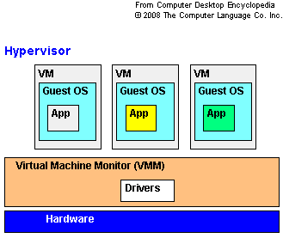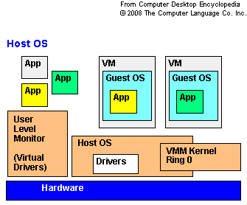
Type 1 Hypervisor Type 2 Hypervisor
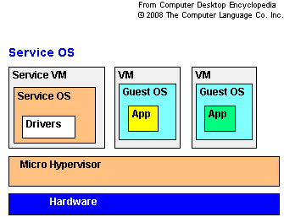
Hybrid Hypervisor
Figure 1 – Classification of Virtual Machine Monitor.

Type 1 (native) Hypervisor
Type 1 hypervisor is software systems that run directly on the host’s hardware as a hardware control and guest operating system monitor, in which guest OS run on the layer above the hypervisor as shown in figure 1. It can achieve higher virtualization by dealing directly with the hardware.

Type 2 (hosted) Hypervisor
Type 2 hypervisor, as shown in figure 1, is software application running within a conventional OS environment. The advantage of Type 2 Hypervisor is the support of a broad range of I/O devices from the Host OS. It is commonly used in client system.

Hybrid Hypervisor
Hybrid Hypervisor combines the robustness of the type 1 model with the flexibility of the type 2 model. One example is Service VM, which is shown in figure 1.

  - PRODUCT AND PROJECT
In this section, we provide a list of virtual machine monitor project.
Name | Host CPU | Guest CPU | Host OS(s) | Guest OS(s) | Technique used | License
Bochs | Any, just need to be compiled | x86, x86-64 | Windows, Windows Mobile, Linux, IRIX, AIX, FreeBSD, OpenBSD, BeOS, Mac OS X | DOS, Windows, *BSD, Linux | Emulation | LGPL
Zones | x86, x86-64, SPARC | x86 | Solaris 10 | Solaris (8, 9 or 10), Linux | OS-level virtualization | CDDL
Cooperative Linux | x86 | x86 | Windows 2000, XP, 2003, Vista^{[1]} | Linux | Porting | GPL v2
DOSBox | any | x86 | Linux, Windows, Mac OS X, BeOS, FreeBSD, OpenBSD, Solaris, QNX, IRIX, MorphOS, AmigaOS | Internally emulated DOS shell. Classic PC booter games and unofficially, Windows 1.0 to 3.11 | Emulation | GPL
DOSEMU | x86, X86-64 | x86 | Linux | DOS | Emulation | GPL v2
GXemul | any | ARM, MIPS, M88K, PowerPC, SuperH | Unix-like | NetBSD, OpenBSD, Linux, Ultrix, Sprite | Emulation | BSD
Hercules | any | z/Architecture | Unix-like | Linux on zSeries, z/OS, z/VM, z/VSE, OS/360, DOS/360, DOS/VS, MVS, VM/370, TSS/370. | Emulation | QPL
Hyper-V | x64 + hardware-assisted virtualization (Intel VT or AMD-V) | x86, x86-64 | Windows 2008 w/Hyper-V Role, Windows Hyper-V Server | Supported Drivers for Windows 2000, Windows 2003, Windows 2008, Windows XP, Windows Vista, Linux (SUSE 10 Released, More Announced)) | Hypervisor Type I | Proprietary (free of charge with Windows Server 2008)
JPC (Virtual Machine) | Any running the Java Virtual Machine | x86 | Java Virtual Machine | DOS | Emulation | GPL v2
KVM | x86 , x86-64, s390,PowerPC | same as host | Linux | Linux, Windows, FreeBSD, Solaris | Para-virtualization + In-kernel virtualization | GPL v2
LinuxOnLinux | Itanium | compatible | Linux | Linux | Paravirtulization + Hypervisor Type II | GPL
Linux- VServer | x86, X86-64, Alpha, PowerPC/64, PA-RISC/64, SPARC/64, ARM, S/390, SH/66, MIPS | compatible | Linux | Various Linux distributions | OS-level virtulization | GPL v2
Logical Domains | UltraSPARC T1, UltraSPARC T2 | compatible | Solaris 10 | Solaris, Linux (Ubuntu Server 7.10), and FreeBSD (experimental) | Paravirtualization | ?
Mac-on-Linux | PowerPC | PowerPC | Linux | Mac OS X, Mac OS 7.5.2 to 9.2.2, Linux | Full-virtulization | GPL
Mac-on-Mac | PowerPC | PowerPC | Mac OS X | Mac OS X, Mac OS 7.5.2 to 9.2.2, Linux | Full-virtulization | GPL
OpenVZ | Intel x86, X86-64, IA-64, PowerPC64, SPARC/64 | Same as host | Linux | Various Linux distributions | OS-level virtulization | GPL
Oracle VM | Intel x86, x86-64, Intel VT-x | Intel x86, x86-64, Intel VT-x | none (bare metal install) | Microsoft Windows, Oracle Enterprise Linux, Red Hat Enterprise Linux | Paravirtulization +  HW virtulization | Free, Commercial
Parallels Desktop for Mac | Intel x86, Intel VT-x | Intel x86 | Mac OS X (Intel) | Windows, Linux, FreeBSD, OS/2, eComStation, MS-DOS, Solaris | Hypervisor Type II | Proprietary
Parallels Workstation | x86, Intel VT-x | x86 | Windows, Linux | Windows, Linux, FreeBSD, OS/2, eComStation, MS-DOS, Solaris | Hypervisor Type II | Proprietary
PowerVM | POWER4, POWER5, POWER6, PowerPC 970 | POWER4, POWER5, POWER6, PowerPC 970, X86 (PowerVM-Lx86) | hardware / firmware, no host OS | Linux-POWERPC, Linux-X86, AIX, i5/OS, IBM i | Hypervisor Type II | Proprietary
QEMU | x86, X86-64, IA-64, PowerPC, Alpha, SPARC 32 and 64, ARM, S/390, M68k | x86, X86-64, ARM, SPARC 32 and 64, PowerPC, MIPS | Windows, Linux, Mac OS X, Solaris, FreeBSD, OpenBSD, BeOS | Changes regularly [6] | Emulation | GPL/LGPL
QEMU w/ kqemu module | Intel x86, X86-64 | Same as host | Linux, FreeBSD, OpenBSD, Solaris, Windows | Changes regularly [7] | In-kernel virtualization | GPL/LGPL
QEMU w/ qvm86 module | x86 | x86 | Linux, NetBSD, Windows | Changes regularly | In-kernel virtualization | GPL
RTS Hypervisor | x86 | x86 | none: bare metal installation | Windows XP, XP-Embedded, Linux, VxWorks, Windows CE, ETS, OS-9 and proprietary OS | Hypervisor type I | Proprietary
Sun xVM Server | x86-64, SPARC | (Same as host) | none (bare metal with Solaris as special guest providing backend drivers to guests) | Windows XP & 2003 Server (x86-64 only), Linux, Solaris | Paravirtulization + Porting + HW virtualization | GPL v3
User Mode Linux | x86, x86-64, PowerPC | (Same as host) | Linux | Linux | Porting | GPL v2
Sun xVM VirtualBox | x86, x86-64 | x86, (x86-64 only on VirtualBox 2 with hardware virtualization) | Windows, Linux, Mac OS X (Intel), Solaris, eComStation | DOS, Windows, Linux, OS/2, FreeBSD, Solaris | Full-virtulization | GPL v2; full version
Virtual PC 2007 | x86, x86-64 | x86 | Windows Vista (Business, Enterprise, Ultimate), XP Pro, XP Tablet PC Edition | DOS, Windows, OS/2, Linux(Suse, Xubuntu), OpenSolaris(Belenix) | Full-virtualization | Proprietary (free of charge) from Jul 2006)
Virtual PC 7 for Mac | PowerPC | x86 | Mac OS X | Windows, OS/2, Linux | Full-virtualization | Proprietary
VMware ESX Server | X86, x86-64 | x86, x86-64 | none (bare metal install) | Windows, Linux, Netware, Solaris, FreeBSD, ... | Hypervisor Type I | Proprietary
VMware ESXi Server | x86, x86-64 | x86, x86-64 | none (bare metal install) (embedded) | Windows, Linux, Netware, Solaris, FreeBSD, ... | Hypervisor Type I | Proprietary (Free)
VMware Fusion | x86, x86-64 | x86, x86-64 | Mac OS X (Intel) | Windows, Linux, Netware, Solaris, others | Hypervisor Type II | Proprietary
VMware Server | x86, x86-64 | x86, x86-64 | Windows, Linux | DOS, Windows, Linux, FreeBSD, Netware, Solaris, Virtual appliances | Hypervisor Type II | Proprietary (Free)
VMware Workstation 6.0 | x86, x86-64 | x86, x86-64 | Windows, Linux | DOS, Windows, Linux, FreeBSD, Netware, Solaris, Darwin, Virtual appliances | Hypervisor Type II | Proprietary
VMware Player 2.0 | x86, x86-64 | x86, x86-64 | Windows, Linux | DOS, Windows, Linux, FreeBSD, Netware, Solaris, Darwin, Virtual appliances | Hypervisor Type II | Proprietary (Free)
Wind River hypervisor | x86, PowerPC | (Same as host) | bare metal | Linux, VxWorks, bare metal virtual board | Hypervisor Type I | Proprietary
Wind River VxWorks MILS Platform | PowerPC | (Same as host) | bare metal | VxWorks, bare metal virtual board | Paravirtualization | Proprietary
XEN | x86, X86-64, (PowerPC and IA-64 ports in progress) | (Same as host) | NetBSD, Linux, Solaris | FreeBSD, NetBSD, Linux, Solaris, Windows XP & 2003 Server (needs vers. 3.0 and an Intel VT (Vanderpool) or AMD-V (Pacifica)-capable CPU), Plan 9 | Paravirtulization  +  Hypervisor Type II | GPL
z/VM | z/Architecture | z/Architecture  ( the new one ) | with or without OS, with  different deep | Linux on zSeries, z/OS,  z/VSE, z/TPF, z/VM,  VM/CMS, MUSIC/SP,  OpenSolaris for System z,  and predecessors | Full-virtualization  +  Hypervisor Type I | Proprietary  One time  Charge +  Maintained  support
LPARs | z/Architecture | z/Architecture | Intrinsic feature of System z mainframes | Linux on zSeries, z/OS, z/VSE, z/TPF, z/VM, VM/CMS, MUSIC/SP, and predecessors | HW Hypervisor | Intrinsic feature of System z mainframes

  - BENEFIT FROM VIRTUALIZATION
Uniform view of underlying hardware
VMM can provide a uniform view of underlying hardware regardless of vendors and architecture by techniques like exporting conventional interface. Through VMM, hardware can be viewed as a pool of resource, where administrators do not need to take care of the coupling of hardware and system software. Disco [10] paper has shown VMM can virtually convert underlying massive multiple processing (MPP) machine to conventional interface that commodity OS can utilize.

Encapsulation
VMM can provide complete encapsulation of virtual machine software states, so that VM can be suspended and resumed without any loss of state. Via VM suspension and resumption, VM can be migrated to other physical machine and continue to execute on the fly.

Easy to replicate
As VM can be viewed as a normal file when it is not executing, the mobility of VM can be comparable to a normal file, where it can be easily copied and transmitted via different media. The mobility provides convenience in setting up checkpoint (by coping existing VM at particular point) and rollback (by running saved VM at a particular check point).

Another advantage is user desktop environment can be portable and executed on any VMM, thus giving user more convenience.

Isolation
VMM can provide isolation of applications, where multiple applications can be running on multiple VMs on “one application on one VM” basis. VMM provides the reliability and security needed to ensure crash in any VM will not affect other running VMs. Thus applications can be multiplexed in a more reliable way.

Utilization and cost saving
As mentioned in isolation, previous model adopt either multiple application on one machine that scarifies reliable for higher utilization or one application on one machine to ensure reliability. VMM provides a mean to multiplex application with high reliability and hence increases server utilization rate.

By consolidating multiple services into one machine, the need for purchasing hardware is lowered and enterprises can enjoy cost saving from reduced hardware cost and future management and energy bill and thus lowered Total Cost of Ownership (TCO).

- VMM IMPLEMENTATION ISSUE
Though the benefits are widely seen in Section 3, the implementation of VMM faces different challenges. To start with, Popek and Goldberg [3] have stated a virtual machine monitor need to satisfy three essential characteristics.

Equivalence property
Any program that runs on top of VMM should perform indistinguishable as if the program is run directly on top of native hardware and the program will have the freedom to access to privileged instructions that it intends. Equivalence property offers two exceptions, timing, which VMM intervention will prolong program execution time and resource availability, which program may need to wait for shared resource to be available.

Efficiency property
All innocuous instructions should be executed by the hardware directly, with no intervention at all on the part of VMM. It is important as the cost of instruction emulation will bring high overhead from translation and interpretation. If majority of instructions need to be emulated, the performance cannot match to those running on native hardware.

Resource control property
It is impossible for any program to affect system resources, e.g. memory and VMM has full control over underlying resource.

In this section, we will discuss various techniques to achieve the three properties stated and their tradeoffs, including performance, compatibility and simplicity.

  - CPU Virtualization
As stated in Popek and Goldberg paper [3], a CPU architecture is virtualizable if all instructions can be directly and equivalently executed. To better illustrate the situation, Popek and Goldberg define three types of instructions, user, sensitive and privileged instructions. Considering VM and guest OS kernel is running in the CPU’s unprivileged mode and VMM is running in CPU’s privileged mode, while guest OS execute unprivileged (user) instructions, the effect will be the same as they are also run in unprivileged mode without VMM. While guest OS execute privilege instructions, CPU will trap into VMM, which emulates the privileged instruction based on the virtual machine state (trap-and-emulate). However, when guest OS executes sensitive instruction in unprivileged mode, the instruction will not trap and may behave differently (which is referred as ring aliasing problem). Thus, Popek and Goldberg state if a CPU architecture is virtualizable if the set of sensitive instructions is a subset of privileged instructions.

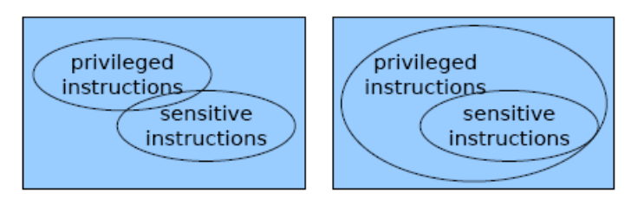
Figure 2 – non-virtualizable (left) and virtualizable (right) instruction set

Unfortunately, many modern CPU architecture is not designed to be virtualizable, including poplar x86, in which 17 sensitive instructions that do not trap are found [30]. x86 architecture is found to include sensitive instructions that read or write sensitive register and/or memory location such as clock register and interrupt register, e.g. PUSHF and POPF, and sensitive instructions that reference the storage protection system, memory or address relocation system. These allow sensitive instructions to write protected register, which affect other VMs, and erode isolation. Also reading protected registers can expose privilege state and erode the transparency of VMM. These imperfections give rise to following techniques to implement virtualization on CPU architecture that cannot be virtualized.

    - PURE VIRTUALIZATION
Some hardware is designed with the goal to be virtualizable, including IBM/370 [32]. If special privilege mode for VMM is not supported in hardware, pure virtualization normally de-privileges guest OS to run on less privileged level, while VMM is run in most privilege level, as shown in figure 3. As Popek and Goldberg requirement is satisfied in these hardware, direct execution has already guaranteed the equivalency. Thus, unmodified OS can run on top of VMM as if it is run on original hardware. However, the performance overhead can be high due to switching between privilege modes.

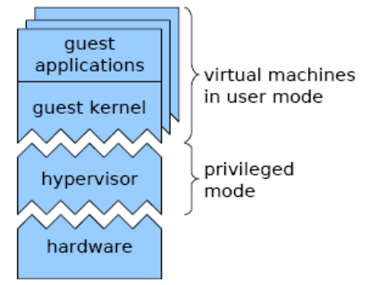
Figure 3 – Pure Virtualization System

    - BINARY TRANSLATION
Binary Translation is applied in hypervisor including VMWare EXS server. The concept behind Binary Translation [33], [13] is to replace code that cannot be directly executed, including, i) PC-relative addressing, ii) Direct control flow, iii) Indirect control flow, iv) Privileged instructions. Under this scheme, binary code blocks are translated on the fly into compiled code fragment (CCF). Performance efficiency is achieved as most of the code are safe and can run identically, while privileged instructions can be replaced by hypercall which avoid privileged instruction trap. Thus VMM with Binary translation will run fast than classical VMM. Adaptive binary translation eliminates the number of trap by following.

- Assume instruction to be innocent until proven guilty
- During execution, VMM detect instruction that trap frequently and adapt their translation
- Retranslate non-IDENT (identical) to avoid the trap
- Patch the original IDENT translation with a forwarding jump to the new translation
Thus trap can be avoided.

Binary Translation does not require guest OS kernel to be modified. At the same time, it maintains low overhead that fits Popek and Goldberg’s efficiency property. However, as functionality needed to be equivalent, the translation process is complicated.

    - PARA VIRTUALIZATION
Para-virtualization is applied on hypervisor including XEN [11] and Denali [12]. The concept of para-virtualization is to achieve better virtualization performance and allow VMM to implement on non-virtualizable hardware by modifying guest OS kernel. This concept introduces co-design of VMM and guest OS, where guest OS aware of the existence of VMM and is modified to be virtualization-friendly, for example, i) guest OS must handle sensitive but non-privileged instructions, ii) guest OS should avoid frequent trap into hypervisor for better performance.

Para-virtualization gains performance by modifying guest OS kernel which causes incompatibility issue, i.e., unmodified OS cannot run on top of para-virtualized VMM and para-virtualized OS cannot run on native hardware as it does not obey the native machine interface as shown in figure 4. In addition, it posts engineering cost modifying kernel. For propriety OS, like Windows, kernel cannot be modified in most circumstances and modified version cannot be released without Vendor’s permission.

The degree of engineering effort varies in different projects. In Disco [10], the modifications, like replacement of POPF instruction to avoid trap, are done in IRIX (guest OS running on top of Disco). The modification is shown to be easy and involve a small degree of change in source code. However, in Denali [12], the interface is very different from hardware, for example, new instruction for idle loop and interrupt semantics are introduced. These deviations make it not trivial to port OS to run on top of Denali.

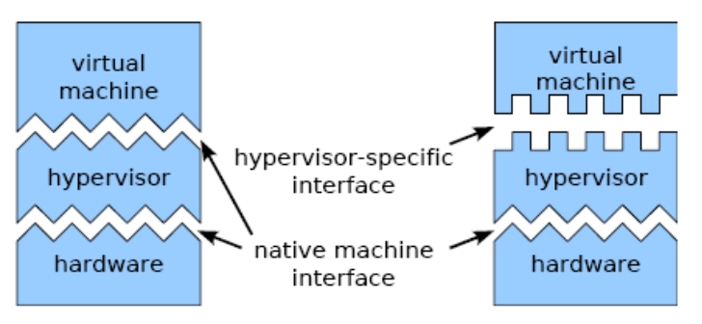
Figure 4 - Comparison between Pure virtualization (left) and Para-virtualization (right)

    - PRE VIRTUALIZATION
Pre-virtualization is initiated in L4Ka project [16] [17]. The concept of pre-virtualization solves compatibility problem by introducing soft-layering principle to improve VMM interoperability. The idea is borrowed from network protocol design, adding modularity to para-virtualization by two conditions.
- it must be possible to degrade to a neutral interface, by ignoring the co-design enhancement (thus permitting execution on raw hardware and hypervisors that lack support for the soft layering)
- the interface must flexibly adapt to the algorithm that competitors may provide (thus supporting arbitrary hypervisor interfaces without pre-arrangement)

With the above conditions, guest OS kernel is designed to prepare for virtualization but also compatible to run on native hardware. To facilitate soft layering, In-Place Virtual Machine Monitor (IPVMM), as show in figure 5d, is developed to mediate between guest OS and VMM. Upon VMM linking, IPVMM rewrites virtualization sensitive code to invoke the appropriate emulation code and forwards incoming interrupts and exceptions to guest OS kernel.

Under this scheme, guest OS compatibility issue is solved as guest OS can be able to run on native hardware or on different para-virtualized VMM via IPVMM. In addition, the modification of guest OS kernel is well defined into instruction level, structural and behavioral and thus can be automated. However, the added layer (IPVMM) will impose extra overhead and the overall performance also depends on the efficiency of IPVMM. From the experiment in L4Ka [16] [17], the overhead imposed is minimal.

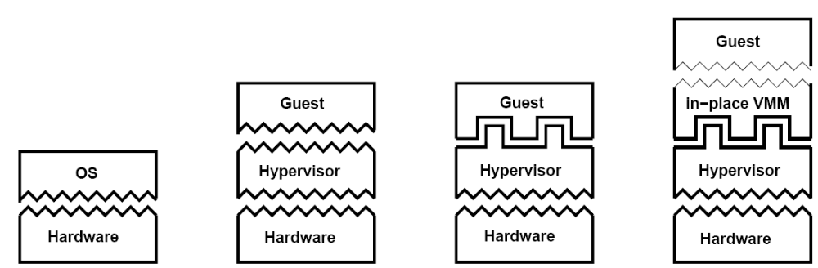
Figure 5 – Comparison of virtualization strategies (left to right): a) native execution – no virtual machine; b) pure virtualization – native hardware interface is preserved; c) para-virtualization – hypervisor specific interface is changed; d) pre-virtualization – a para-virtualizing hypervisor interface is mapped back to the hardware interface by in-place VMM, making the overall hypervisor interface transparent.

    - HARDWARE ASSISTED VIRTUALIZATION
To facilitate the virtualization in CPU, Intel and AMD have sought to eliminate the need for monitoring and translation of instructions. To this end, new instructions have been added. A new control structure, Virtual Machine Control Structure (VMCS) [14], has also made its appearance.
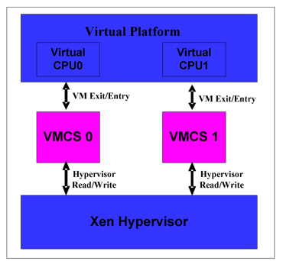
Figure 6 - VMCS Representation in XEN

The program can gain more control by running on lower privilege level. On 32-bit x86 architecture, there are four privilege levels (called rings), namely 0, 1, 2 and 3 (But, rings 1 and 2 have been deteled in x86-64 because they no longer serve) The OS is designed to run on the ring 0, which has the highest level of control. Applications runs on the ring , and they can’t change their level of execution. And an application can not stop the OS while the OS may decide to stop an application.
In a virtualized environment, we have one or several OS. The hypervisor that controls them requires a higher privilege level than the OSes because it controls the physical resources and guest OS. As the hypervisor is the ring 0, guest OS must be placed on a higher ring: 1 or 3. However, the OS are designed to run on the ring 0. In addition, work on a ring below the applications ensures control of those applications.

To resolve this problem, Intel VT technology introduced a new method of execution, called VMX. It has a root level. This level corresponds to what we assume rings that are under ring 0, and a normal level, corresponding to the old rings from 0 to 3. The hypervisor runs in VMX root level that has more control. The guest operating systems run on the ring 0, which are on VMX normal level. So this way, VMM and guest OS work each on the privilege level that they are designed to run on. Then no more changes are needed for the Guest OS, e.g. binary translation.
The new instructions allow the processor to switch to a new mode of execution, guest mode execution. This mode has also four different levels of privileges. So it deletes the problems associated with the implementation of guest OS in a different privilege level. When it is needed, the processor switches to the guest mode execution. To do so, the VMM should set the control bits that are responsible to switch to this mode, those its are stored in the VMCS. At the time of switching between the OSes, the state of the guest OS is stored in the VMCS and and the state of the other guest OS is loaded from the VMCS.
Intel and AMD claim that this way they increase the speed of the hypervisor. However, tests conducted by VMware tend to show that the gain is not so obvious. The gain is much clearer with Parallels Workstation, stated some testers. For example, the number of cycles of calculation used by VM entry instructions, VM exit, VMCS read, write VMCS has been divided by two between the Pentium 4 and Core 2 Duo.
  - Memory Virtualization
In memory virtualization, there are few challenges including implementation of shadow page table, reclaiming memory and reducing memory waste on storing redundant copies of code and data.

Virtual Page Table
When installed on a single machine, the Operation System manages the access to the physical memory. This addressing is performed on a virtual memory, called linear memory. This memory represents the total available memory, whether it's on one or two memory slots or on the hard disk. The correspondence between the linear memory and physical memory is performed by a unit of the CPU, the MMU (Memory Management Unit). The MMU maintains the mapping between the physical address and linear addresses requested by the OS, called the page table.
Operating Systems use the memory addresses starting always at zero. To avoid conflicts access between different OS running simultaneously, the hypervisor intercept all access from the OSes to the MMU and reinterprets them. The VMM construct then for every OS [13], a false page table which maps linear addresses requested by the OS to the reserved shrink. This intermediate mapping table is called Shadow Page Table (SPT). A simple memory access becomes a complex operation:
* With virtualization:
1.
Guest OS linear address ========> Host OS linear address

2.
Host OS linear address ==========> Physical linear address

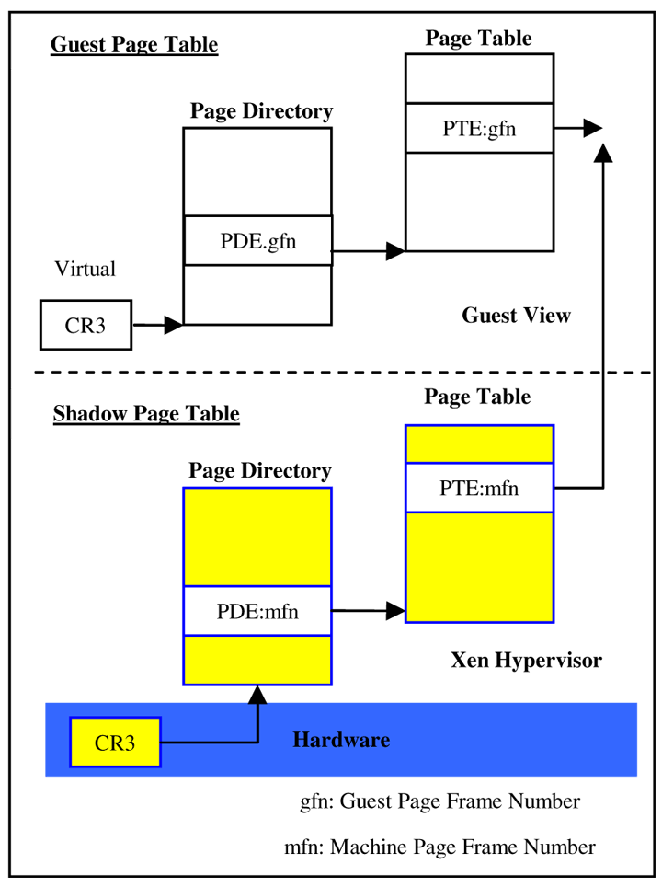
Figure 7 - Shadow Page Table

Extend Page Table (Intel)
To reduce the work of the VMM, Intel and AMD have invented Extended Page Tables (EPT) and Nested Page Tables (NPT) [13]. In both cases it's a hardware implementation of the SPT, and most of the known hypervisors are already taking use of it. These tables can actually dedicate a portion of physical addresses of memory for each guest OS. They can then access to their own area memory space without the intervention of the VMM. All the physical memory address of Guest OSes are recompiled in the EPT. It works as follows:
1. Guest OS linear address ==========> Guest OS physical address

2. Guest OS physical address ========> Host OS physical address

Reclaiming Memory
As VMM needs to constantly control the amount of memory allocated for VM, VMM must periodically reclaim some of the memory by paging a portion of VM out to the disk. However, comparing with guest OS, VMM lacks information, like pages own by exited process, to determine which page is good candidate for paging out.

VMWare suggests a para-virtualization approach, in which a balloon process running inside Guest OS that can communicate with VMM. When VMM need to reclaim memory, it signals the balloon process to inflate and thus Guest OS will replace memory page to the balloon process.

Content based Page Sharing
Running multiple guest OS can impose memory overhead as multiple copies of identical code and data are loaded, especially when running same OS with multiple instances. To address this issue, Disco [10] introduce a memory sharing technique where VMM tracks the contents of physical page and share the page if the request is found to be identical on a copy-on-write basis.

  - I/O Virtualization
One of the major subjects of virtualization is the access to the hardware devices. Indeed, the VMM used to use a generic device driver for all VM without taking into consideration the hardware devices. Guest OS see only virtual devices, emulated by the VMM, and all their requests go to the VMM which then redirects it to the hardware. Virtualizing devices (I/O virtualization) would allow mounting directly a device on a virtual machine. Again, we can expect very significant gains in terms of overhead, and this is already done with some of proprietary hypervisors, like Logical Domains, which has one of the most negligible overhead, thanks to the new hardware specifications, optimized and designed for virtualization [34]. With LDoms, we can bind some resources statically or dynamically for each Guest OS. I/O devices can be bounded before starting the OS, and also mounted after. Each Virtual CPU (that corresponds to a physical thread) can be allocated or dislocated dynamically (Hot-plug) to/from the Guest OS. For more details please refer to the "Admin Guide" of "Logical Domains 1.0.3" [18].

An assisted switching
Another contribution of Virtualization Technology (Intel VT) is the ability to share resources between Guest Operating Systems. Those OSes are running without the knowledge of the presence of other guests on the same machine. The hypervisor gives each guest a slice of execution time, then suspended, and allocates the portion of execution time next to another guest and so on. This imposes to safeguard and restore the context switches each of the guests (the state of registers and caches, for example): take a picture of the state of the system, store, and restore activity. This type of running is the one used to run multiple Operating Systems on one core processor, or generally where the number of operating systems running is higher than the number of available cores. The idea behind creating VT instruction is also to perform virtualization faster.

- SECURITY CONCERN
While practitioners enjoying the benefits brought by virtualization from multiplexing services, forming checkpoint and rollback, dynamic migration, pre-configured application distribution and multiple isolated testing environments, researchers continues to open up opportunities and challenges in virtualization technology.

Opportunity
Researches including [24], [37], [38], use virtual machines to detect instruction, such as, LiveWire [24]. LiveWire is an Intrusion Detection System (IDS) that runs on top of VMM as shown in figure 6. The research pinpoints implementing IDS with VMM has advantages over conventional approaches that IDS resides in host system or network. The paper assure VMM to be difficult to attack compare with modern OS due to
- Simple and Constrained Interface
- Simple Protection Mode
- Simple architecture and small code size

Thus, Virtual Machine Introspection (VMI) can provide better isolation compare with host system approach so that malware can hardly attack IDS. It also offers better visibility compare with network approach so that IDS can inspect hardware and guest OS software state and event via VMM.

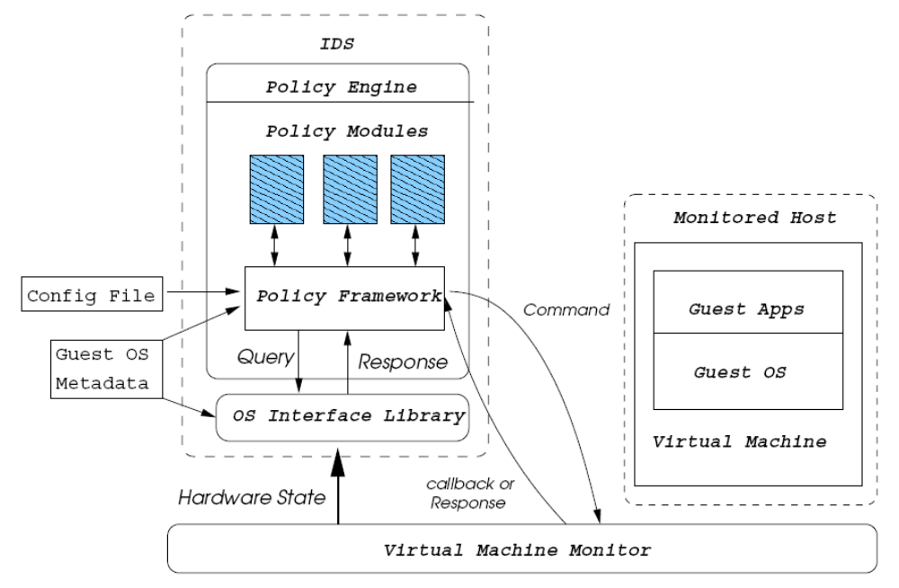
Figure 8 – High-Level View of LiveWire VMI based IDS architecture.

In additional to new design of IDS, users can be benefitted from running different security level application in different VMs. For example, user can use one separated VM for security transaction, e.g. online banking, while another VM for web surfing. VMM isolation property secures the online banking VM from web surfing VM even it is perturbed by malware. Terra [25] has put one step further by implementing trusted VMM that offers two types of VM, i) Open VM, performs similar to other VM, ii) Closed VM, offers additional security features including, root secure, attestation and trusted path.

CHALLENGES
Security challenges in virtualization mainly come from two aspects, malware using virtualization technology to attack the system, and human behavior.

In the malware perspective, as suggested in Subvirt [26], Layer-below attack can be use to compromise VMM. By accessing or controlling a layer of software that is below defense mechanism, an attacker can avoid or disable defense. This type of attack in VMM is defined as Virtual-machine based rootkit (VMBR), in which VMBR is running one layer below the OS or IDS as shown in figure 7. After successful intrusion, VMBR enables malicious services that can be, i) service need not interact with target system, like spam replays, ii) service that observe information about the target system, like logging network packet, iii) service that perturbs the execution of target system, like modifying target system data.

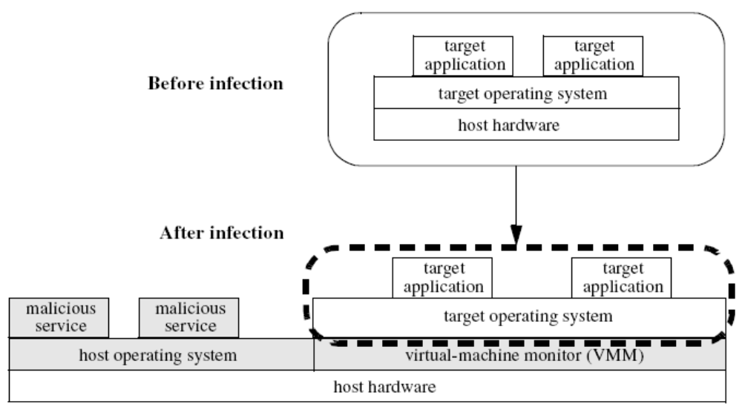
Figure 9 – System infected by Virtual-machine rootkit (VMBR), shown in grey.

Therefore, it is needed to develop methods to detect and defend from VMBR. For VMBR defense, it is suggested as the difficulty in implementing nested virtualization in VMBR, system that has VMM deployed will be safe from the attack. For VMBR detection, two methodologies are suggested.

Detect by side-channel information
As VMBR is a special type of VMM, guest OS running on top of VMBR will have similar properties or constraints as if they are running on VMM. [41] [42] [43] use the time overhead from CPU using trap-and-emulate for privileged instruction, benchmark on the time and deduce if the system is perturbed. Other attempts to use memory overhead, but this approach is not successful as the memory overhead for VMBR is not significant for detection.

Detect by sensitive but non-privileged instruction
This detection use the loophole of VMBR that may not fully virtualize all sensitive but non-privilege instructions as defined by Popek and Goldberg. It is found that these instructions behave different in different privilege mode. RedPill [40] detects if system is run in the presence of a VMM by using sidt instruction (and there are multiple instructions that can be used). The sidt instruction reads the address of processor’s interrupt descriptor table. This address is different for an OS running directly above hardware than for an OS running above VMM. Thus, presence of VMM can be detected by running sidt instruction in user mode.

However, with the new hardware support on virtualization, including Intel-VT [14] and AMD-V [15], newer VMBR makes use of the new hardware to evade from detection, including BluePill [39]. BluePill is a Hardware-assisted Virtual Machine Rootkit (HVM rootkit) that runs in the new more privileged mode for hypervisor, Ring -1 supported by Intel VT and AMD V, as shown in figure 8. It has an advantage over Subvirt that it does not require reboot and can be placed on the fly by exploiting protected driver to run in VMX mode (Ring -1). With hardware support, sensitive but non-privileged instructions behave correctly and thus HVM rootkit can evade from the detection of RedPill.

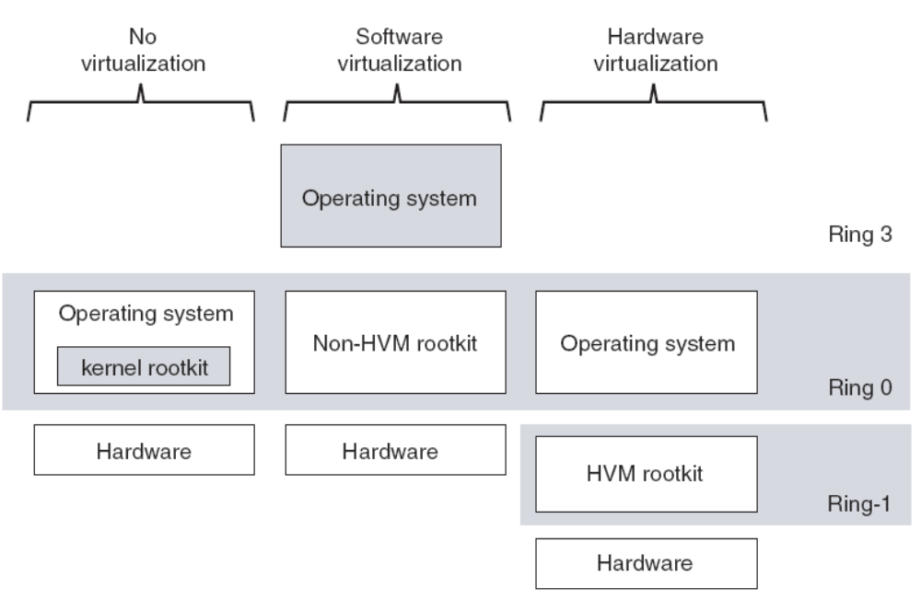
Figure 10 – Comparison between rootkit without (middle) and with (right) hardware support.

It is argued [36] [41] that even though there is a potential threat on VMBR, detection for system without Hardware-assisted support is effective, e.g. RedPill. And for system with Hardware-assisted support, threat can be eliminated by installing VMM in advance. GuardHype [44] suggests integrating virtualization based security service into VMM to avoid possible infection from VMBR.

In behavior aspects, it is suggested that virtualization may bring security loophole, including i) random seed reuse during rollback, ii) sensitive data mobility as VM can be easy copied and transmitted, iii) difficulties in patch management as some VM deliberately or un-deliberately running older version [29]. The paper also argues that these security problems could be overlook as previous researches on virtualization and service consolidation focus only on single host or entirely new organizational paradigm.

- CONCLUSION
In this literature research, we have referred to two survey papers in 1994 and 1995 [2] [5]. We extend the survey by focusing on performance and security aspects of virtual machine monitor. The performance aspect leads us to cover researches on software and hardware technique for virtualization and pinpoints how overhead is lowered by techniques including Binary Translation [33] and Para-virtualization [11] [12] and newer hardware technology [13] [14] [15]. The security aspect leads us to researches on using VMM on intrusion detection [24] [37] [38] and secure computing [25]. Lastly, we also explore potential attack and detection of virtual machine based rootkits (VMBR) [26] [39] [40].

- REFERENCES
[1] R.P. Goldberg, “Survey of Virtual Machine Research”, 1974
[2] M Rosenblum, T Garfinkel, “Virtual Machine Monitors: Current Technology and Future Trends”- Computer, 2005 - ieeexplore.ieee.org
[3] Gerald J. Popek and Robert P. Goldberg. Formal requirements for virtualizable third generation architectures. Communications of the ACM, 17(7):412–421, 1974.
[4] JE Smith, R Nair , “The architecture of virtual machines”, Computer, 2005 - ieeexplore.ieee.org
[5] R Rose, “Survey of system virtualization techniques”, Retrieved March, 2004 - robertwrose.com
[6] Poul-Henning Kamp Robert N. M. Watson, “Jails: Confining the omnipotent root”.
[7] Khairil Yusof ,“FreeBSD Jails: Lightweight Virtualization”.
[8] Octave Orgeron (Sun Microsystem) “An introduction to Logical Domains.”
[9] Menno Lageman, “Sun Client Solutions : Solaris Containers — What They Are and How to Use Them”
[10] E Bugnion, S Devine, K Govil, M Rosenblum , “Disco: Running commodity operating systems on scalable multiprocessors”, ACM Transactions on Computer Systems, 1997 - portal.acm.org
[11] P Barham, B Dragovic, K Fraser, S Hand, T Harris , “Xen and the art of virtualization”, ACM SIGOPS Operating Systems Review, 2003 - portal.acm.org
[12] Andrew Whitaker, Marianne Shaw, and Steven D. Gribble. Scale and performance in the denali isolation kernel. ACM SIGOPS Operating Systems Review, 36(SI):195–209, 2002.

[13] K Adams, O Agesen“A comparison of software and hardware techniques for x86 virtualization”, 2006 - portal.acm.org
[14] Rich Uhlig, Gil Neiger, Dion Rodgers, Amy L. Santoni, Fernando C. M. Martins, Andrew V. Anderson, Steven M. Bennett, Alain Kagi, Felix H. Leung, and Larry Smith. Intel virtualization technology. IEEE Computer, 38(5):48–56, 2005.
[15] Advanced Micro Devices, Inc. AMD64 Virtualization Codenamed Pacifica Technology, Secure Virtual Machine Architecture Reference Manual. Austin, TX, USA, 2006.
[16] J LeVasseur, V Uhlig, B Leslie, M Chapman, G Heiser, “Pre-virtualization: uniting two worlds”, Proceedings of the twentieth ACM symposium on Operating systems principles
[17] J LeVasseur, V Uhlig, B Leslie, M Chapman, G Heiser, “Pre-virtualization: software layering for virtual machine”
[18] Logical Domains 1.0.3 Admin Guide
[19] Ashley Saulsbury, “UltraSPARC Virtual Machine Specification”
[20] J. P. Casazza, M. Greenfield, and K. Shi, “Redefining Server Performance Characterization for Virtualization Benchmarking”, Intel Technology Journal, 2006, 10(3):243-252.
[21] D. Gupta, R. Gardner, and L. Cherkasova, “XenMon: QoS monitoring and performance profiling tool”, HP Labs Technical Report, HPL-2005-187, October 2005.
[22] Menon, JR Santos, Y Turner, GJ Janakiraman, Willy Zwaenepoel , “Diagnosing performance overheads in the xen virtual machine environment”, usenix.org
[23] Diwaker Gupta (UC San Diego), Lucy Cherkasova (HP Labs), Rob Gardner (HP Labs), Amin Vahdat (UC San Diego), “Performance Isolation in XEN”.

[24] T Garfinkel, M Rosenblum , “A virtual machine introspection based architecture for intrusion detection”, Proc. Network and Distributed Systems Security Symposium, 2003 - eprints.kfupm.edu.sa

[25] T Garfinkel, B Pfaff, J Chow, M Rosenblum, D Boneh , “Terra: A virtual machine-based platform for trusted computing” - portal.acm.org

[26] ST King, PM Chen , “SubVirt: Implementing malware with virtual machines” - 2006 IEEE Symposium on Security and Privacy, 2006 - ieeexplore.ieee.org

[27] GW Dunlap, ST King, S Cinar, MA Basrai, PM Chen , “ReVirt: Enabling intrusion analysis through virtual-machine logging and replay”,- ACM SIGOPS Operating Systems Review, 2002 - portal.acm.org

[28] C SE, Y RESPONSE , “A Testing Methodology for Rootkit Removal Effectiveness”, symantec.com

[29] T Garfinkel, M Rosenblum, “When Virtual is harder than Real: Security Challenges in Virtual Machine Based Computing Environments”

[30] J. S. Robin, C. E. Irvine, “Analysis of the Intel Pentium Ability to support a Secure Virtual Machine Monitor”, USENUX Security Symposium, pp 129-144, 2000
[31] R. Goldberg. Architectural Principles for Virtual Computer Systems. Ph.D. thesis, Harvard University, Cambridge, MA, 1972.

[32] R. J. Creasy, “The Origin of the Vm/370 Time-Sharing System”, IBM Journal of Research and Development, vol 25, no 5, p 483, 1981
[33] R. Sites er al., “Binary Translation”, Comm, ACM, Feb 1993, pp 69-81
[34] Tony Shoumack, “BEGINNERS GUIDE TO LDOMS: UNDERSTANDING AND DEPLOYING LOGICAL DOMAINS"
[35] T Garfinkel, K Adams, A Warfield, J Franklin , “Compatibility is not transparency: VMM detection myths and realities” - Proceedings of the 11th Workshop on Hot Topics in Operating System - usenix.org
[36] K Skapinetz, “Virtualisation as a blackhat tool”, Network Security, Oct 2007
[37] KG Anagnostakis, S Sidiroglou, P Akritidis, K Xinidis, E Markatos, “Detecting targeted attacks using shadow honeypots”, - usenix.org
[38] A Joshi, ST King, GW Dunlap, PM Chen , “Detecting past and present intrusions through vulnerability-specific predicates”, - Proceedings of the twentieth ACM symposium on Operating System Principles, pp 91-104, 2005 - portal.acm.org
[39] Blue Pill Project, www.bluepillproject.org, Invisible Things Lab
[40] J. Rutkowska, “Red Pill or how to detect VMM using (almost) one CPU instruction”, 2005
[41] P. Ferrie, N. Lawason, T. Ptacek, “Don’t Tell Joanna, The Virtualised Rootkit Is Dead” In Proceedings of Black Hat USA 2007,
[42] A. Seshadri, M. Luk, E. Shi, A. Perrig, L. van Doorn, and P. Khosla. Pioneer: Verifying integrity and guaranteeing execution of code on legacy platforms. In Proceedings of ACM Symposium on Operating Systems Principles (SOSP), pages 1–16, 2005
[43] Y.-M. Wang, D. Beck, B. Vo, R. Roussev, and C. Verbowski. Detecting Stealth Software with Strider GhostBuster. In Proceedings of the 2005 International Conference on Dependable Systems and Networks (DSN), June 2005.

[44] M Carbone, D Zamboni, W Lee, “Taming Virtualization”, - IEEE Security & Privacy, 2008 - ieeexplore.ieee.org

